CS Bridge Module 7 Algorithm Analysis

1. Module 7 Algorithm Analysis

1.1 Title Slide


2. The Primality Testing Problem

2.1 Primality Testing
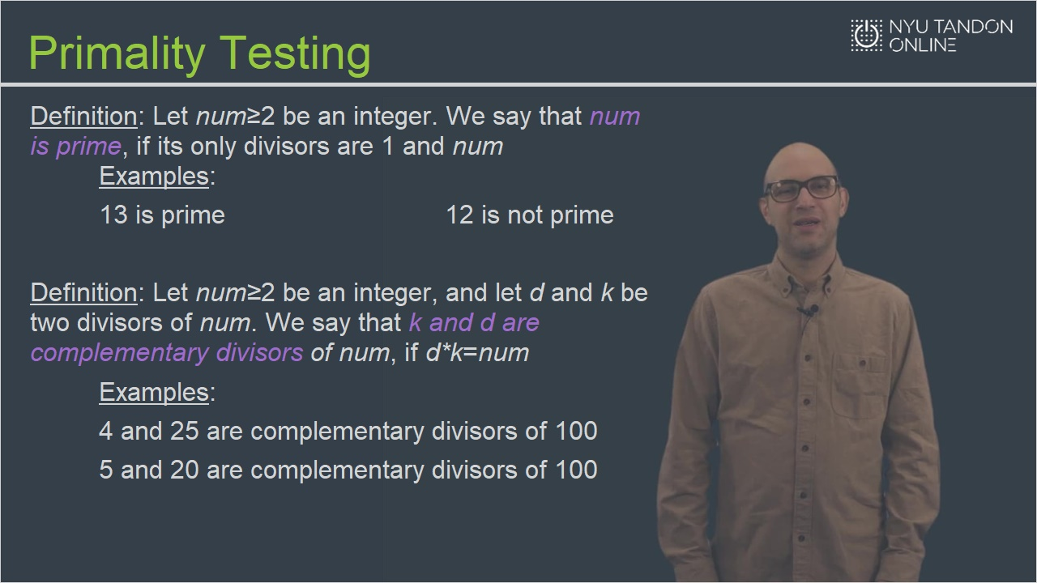

2.2 Primality Testing: Solution 1
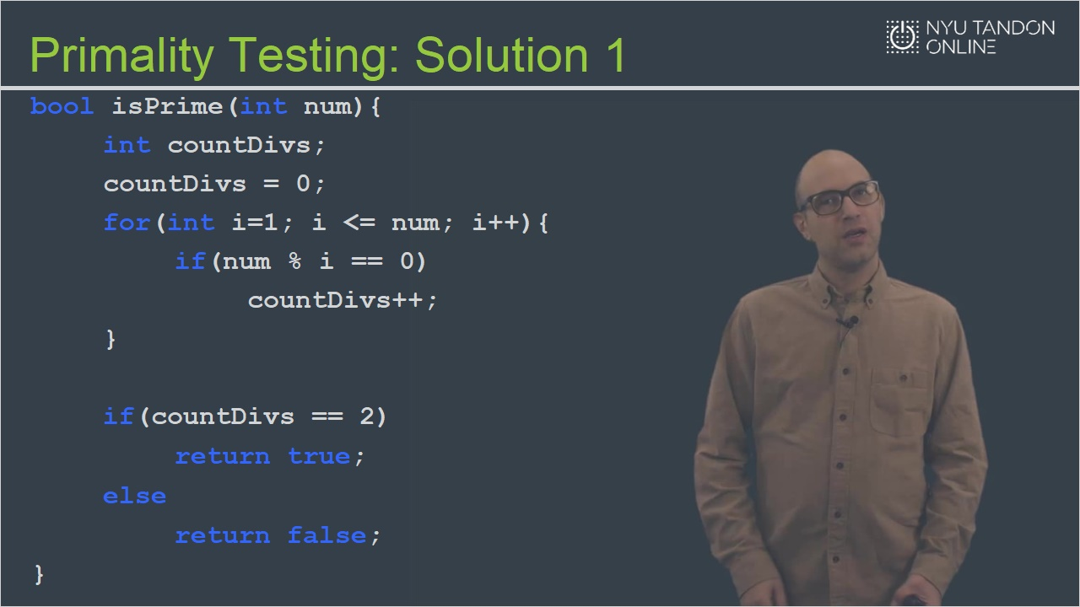

2.3 Primality Testing: Solution 2
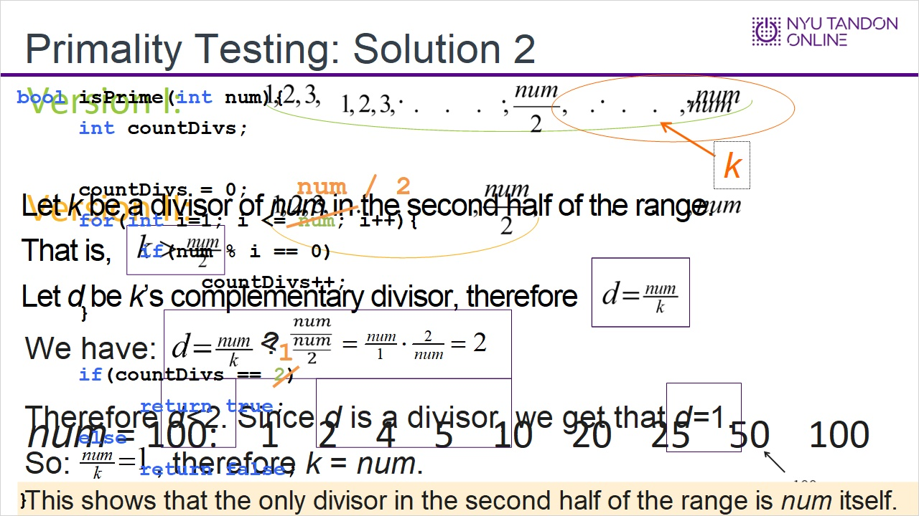

2.4 Primality Testing: Solution 3
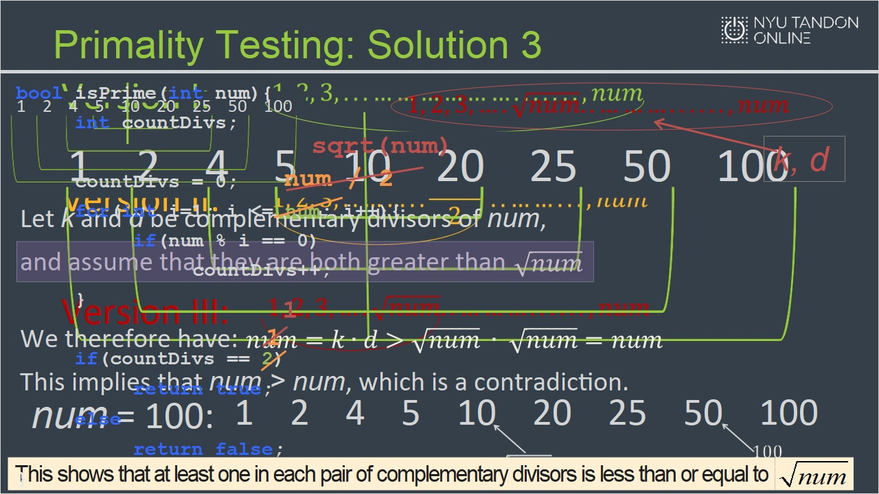

2.5 Runtime Analysis Part 1
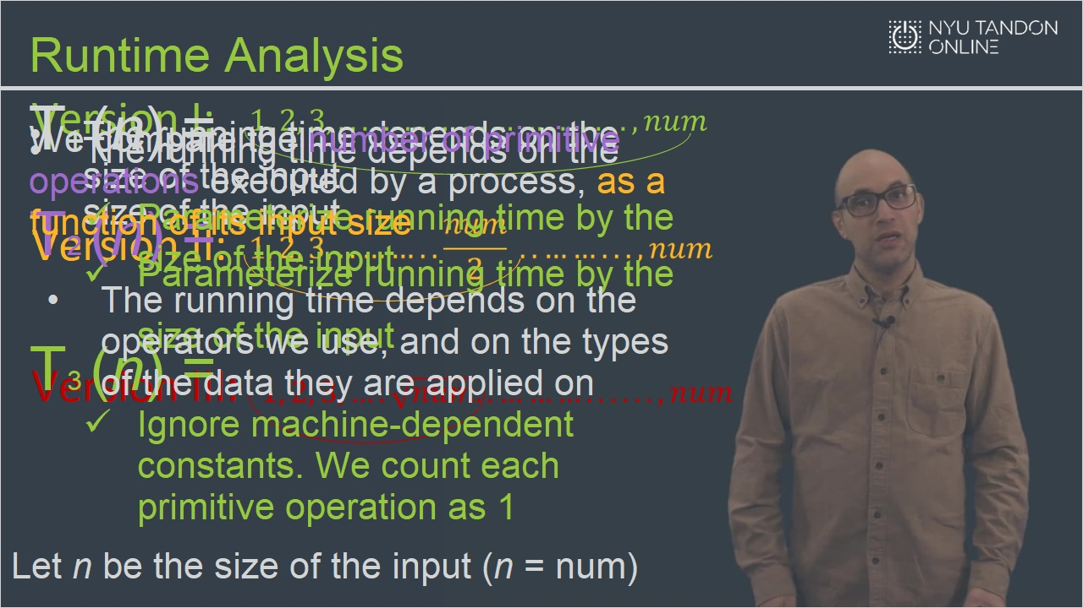

2.6 Runtime Analysis Part 2
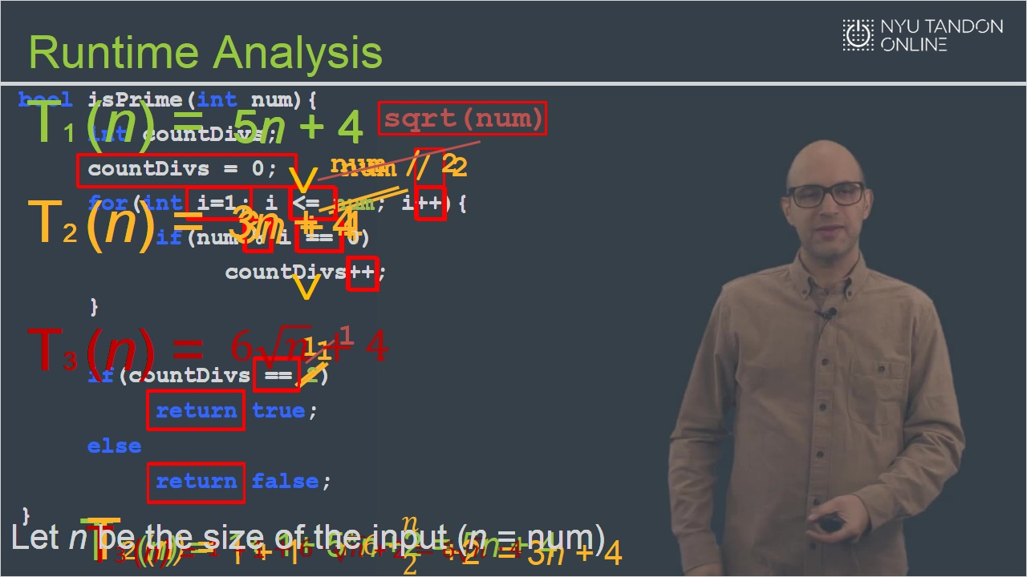

2.7 Runtime Analysis Part 3
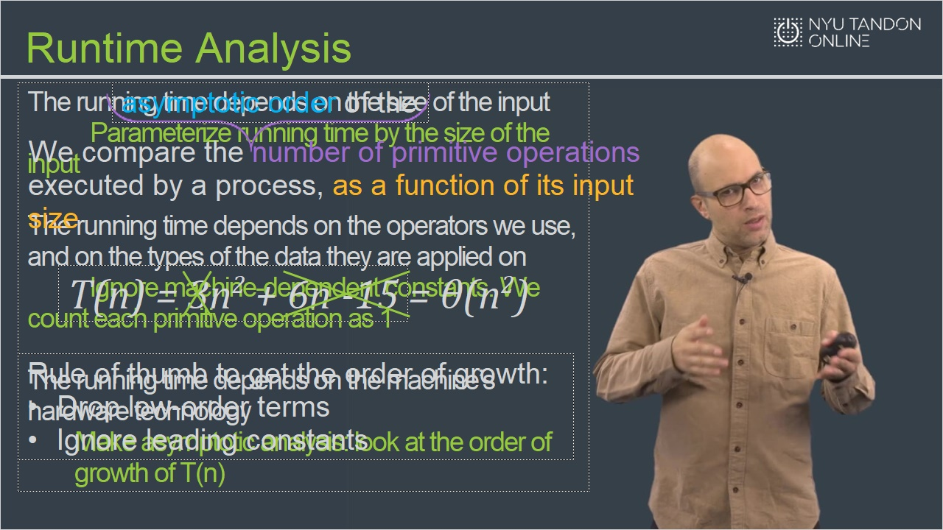

2.8 Runtime Analysis Part 4
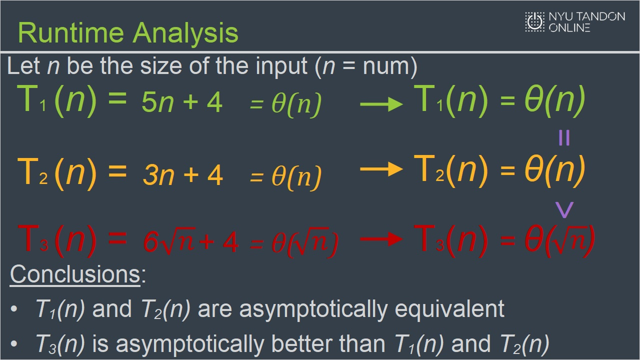

3. Asymptotic Analysis

3.1 Order of Growth: Formal Definition
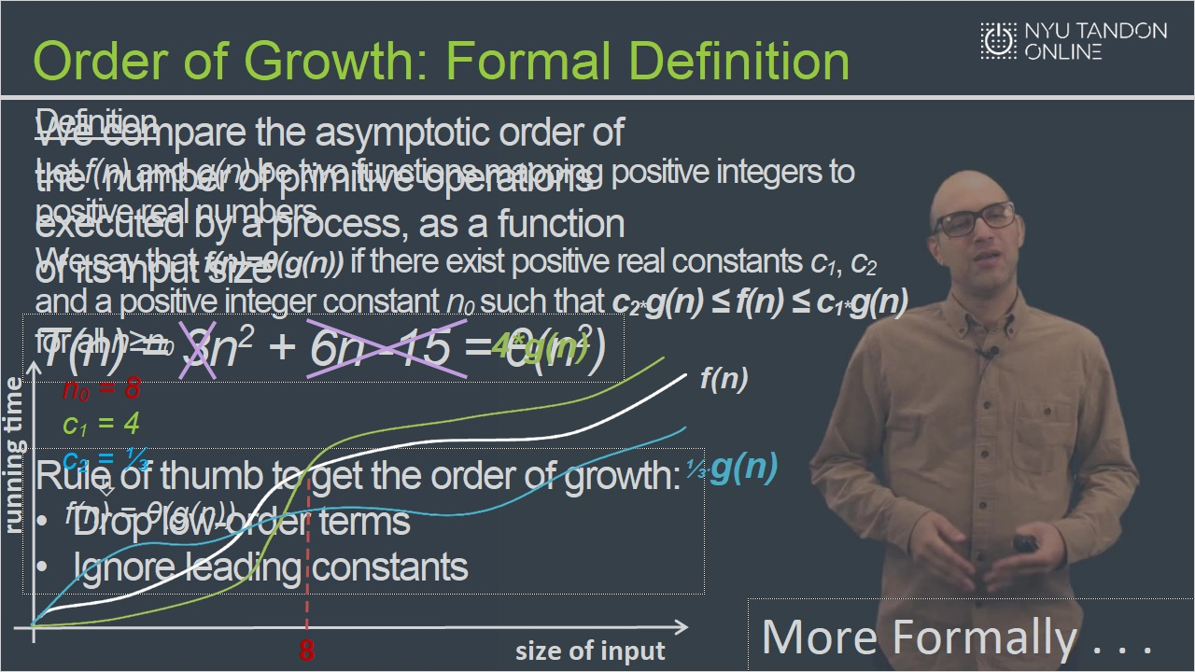

3.2 Asymptotic Analysis Example
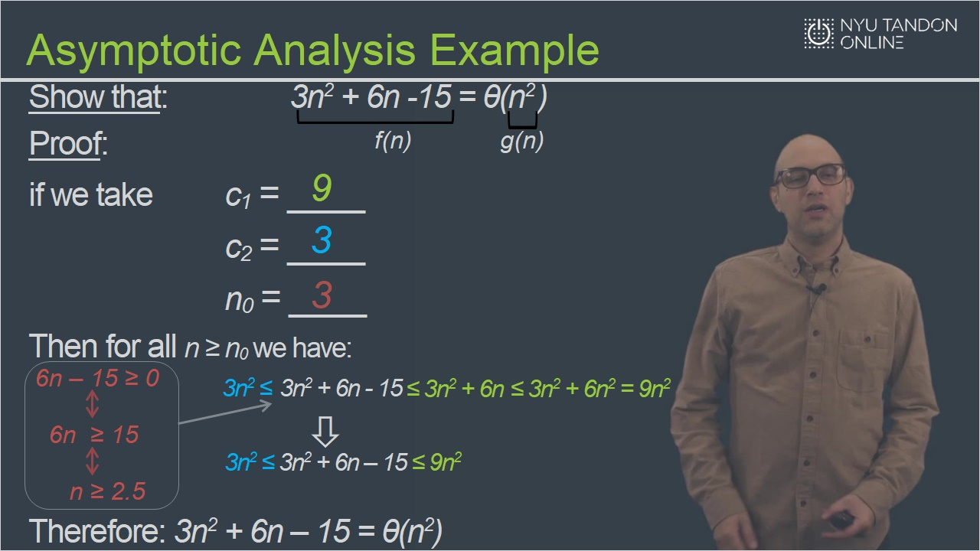
Notes:

4. Runtime Analysis

4.1 Runtime Analysis: Example 1
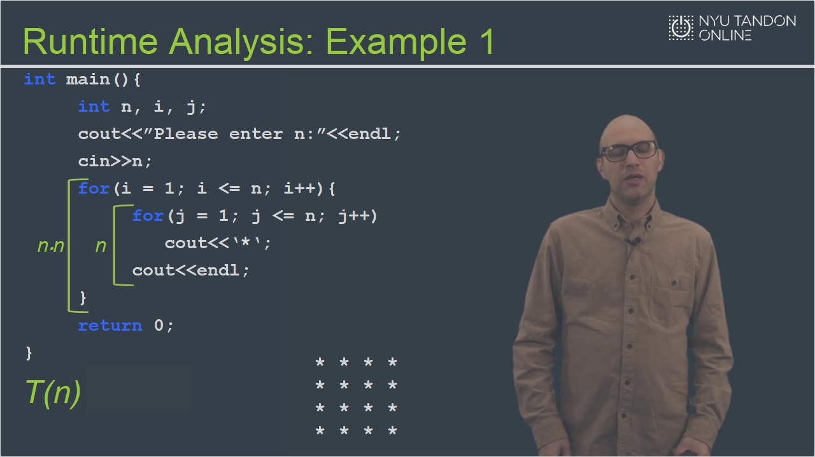

4.2 Runtime Analysis: Example 2
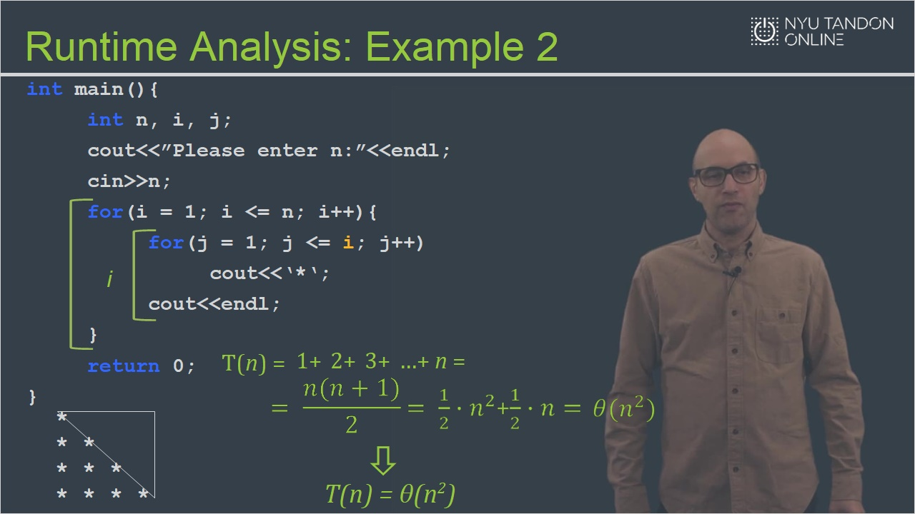

4.3 Knowledge Check
(Fill-in-the-Blank, 10 points, unlimited attempts permitted)
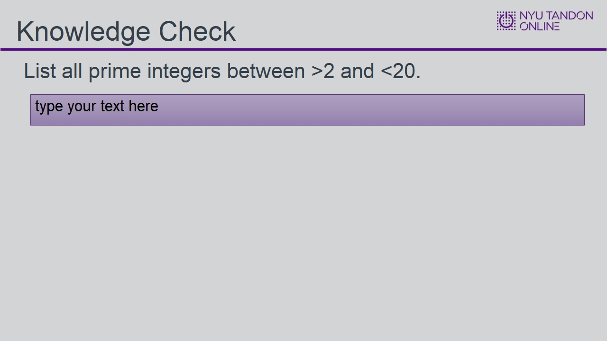
Choice
3, 5, 7, 11, 13, 17, 19
3,5,7,11,13,17,19
3 5 7 9 11 13 17 19
Feedback when correct:
That's right! You selected the correct response.

Correct (Slide Layer)
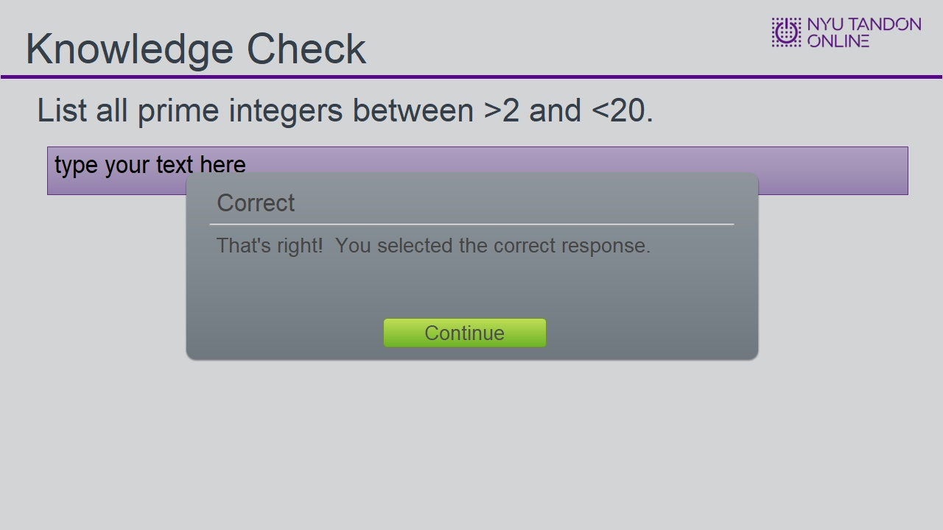

Try Again (Slide Layer)
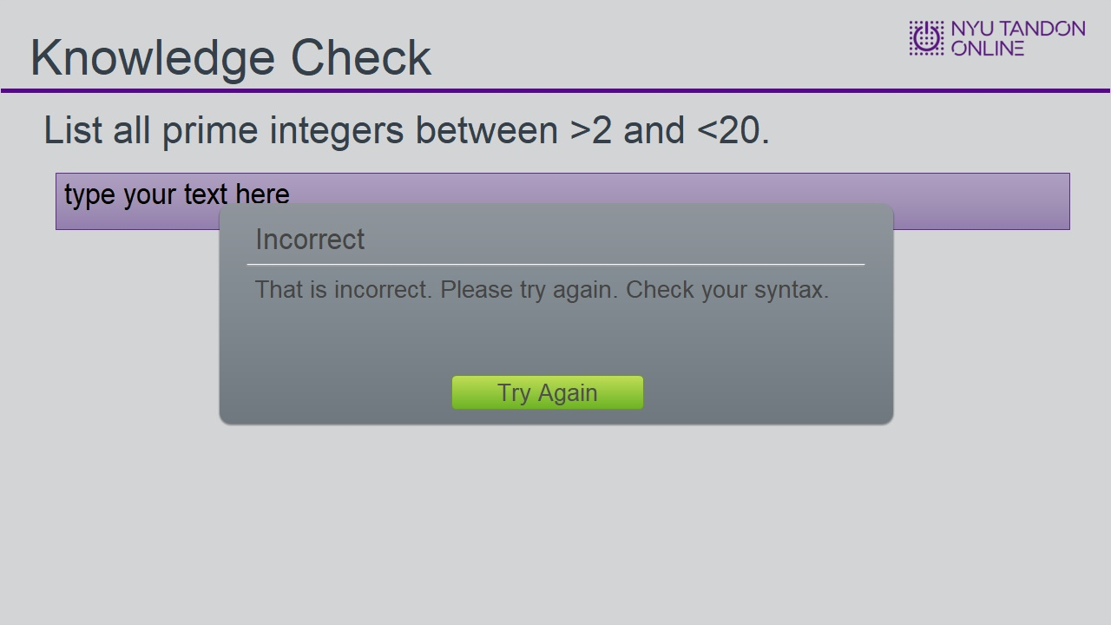

4.4 Knowledge Check
(Multiple Choice, 10 points, 4 attempts permitted)
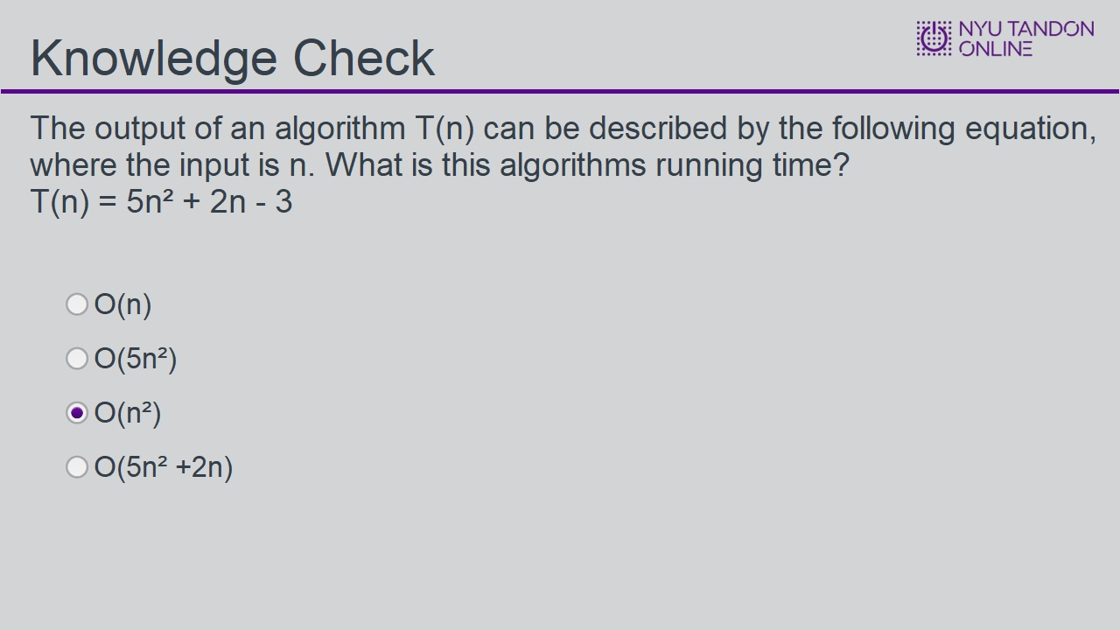
Correct | Choice
 | O(n)
 | O(5n²)
X | O(n²)
 | O(5n² +2n)

Feedback when correct:
That's right! You selected the correct response.

Correct (Slide Layer)
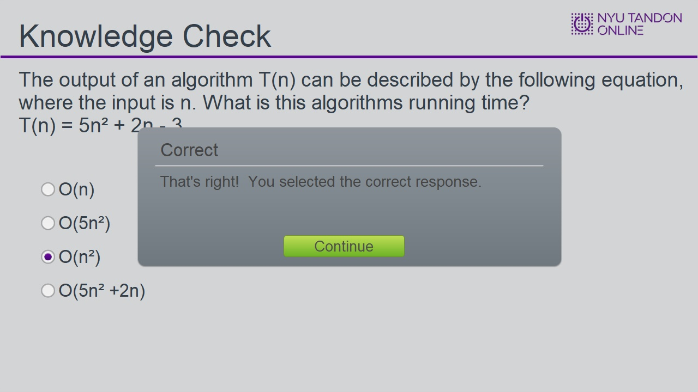

Try Again (Slide Layer)
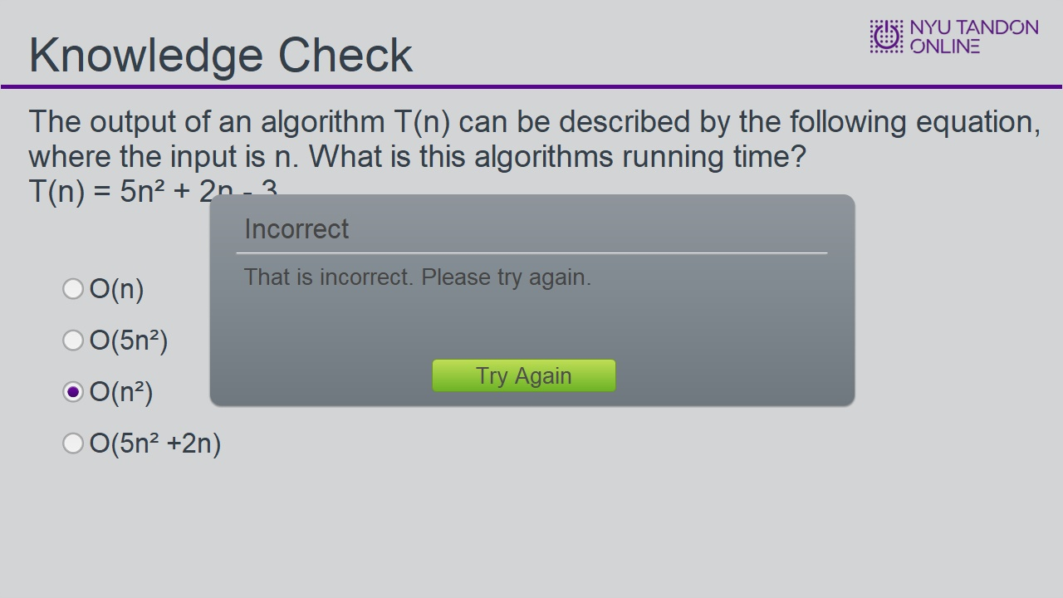

4.5 Results Slide
(Results Slide, 0 points, 1 attempt permitted)
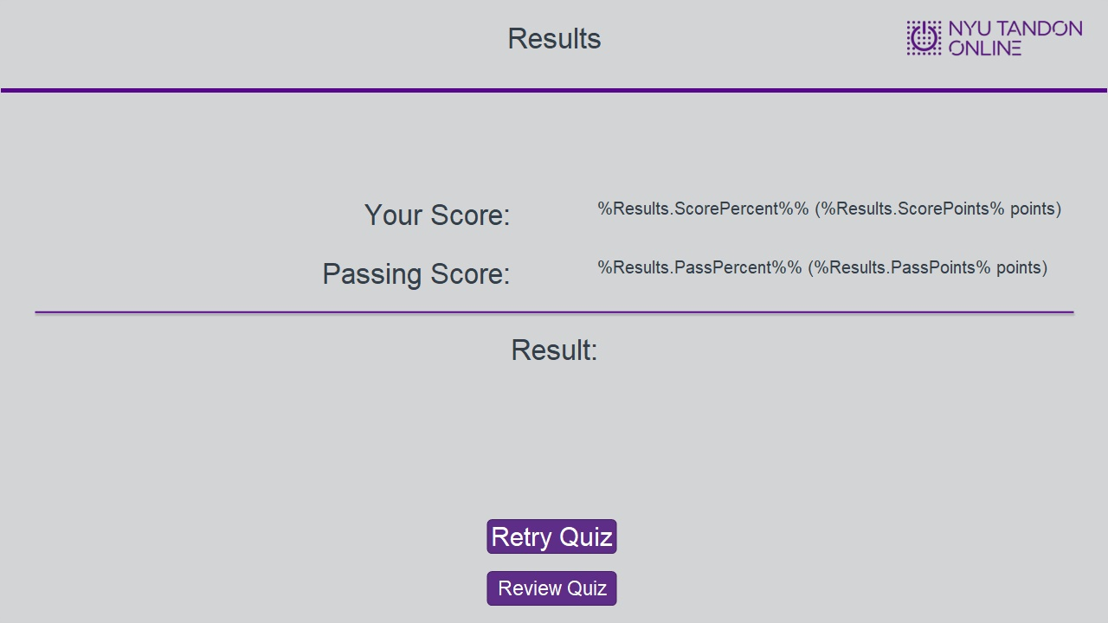

Results for
4.3 Knowledge Check
4.4 Knowledge Check

Result slide properties
Passing  Score | 80%

Notes:

Success (Slide Layer)
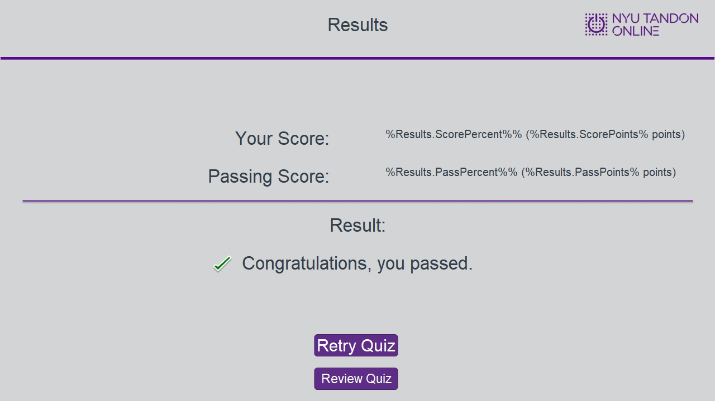

Failure (Slide Layer)
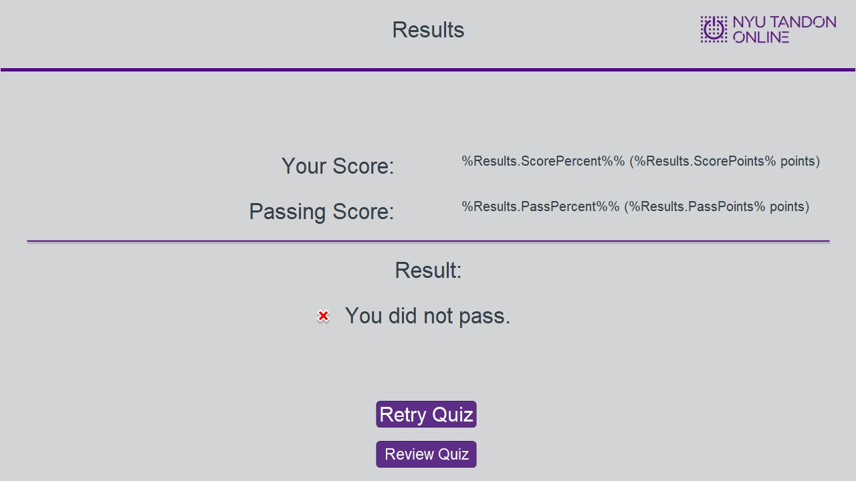

4.6 End of Module


